DELL BOOMI INTEGARTION DOCUMENT

1. **Connecting DataBase and NetSuite with Boomi**
2. **Query Database Tables**

Querying CMS Database for claims

Query: *SELECT AdjusterID, AdjusterName, CMSNo, ClientClaimNumber, ClientName, CreatedDate, InsuredEmail, InsuredLossLocationAddress, InsuredLossLocationAddress2, InsuredLossLocationCity, InsuredLossLocationState, InsuredLossLocationZip, InsuredName, InsuredPhone1, InsuredPhone1Extension, InsuredPhone2, InsuredPhone2Extension, InsuredPhone3, InsuredPhone3Extension, LastClaimActivityTimeStamp, LossDate, PolicyNumber FROM v_ClaimGrid*

*WHERE AdjusterID IS NOT NULL AND ClientName IS NOT NULL AND LastClaimActivityTimeStamp >=?*

1. **Make Decision:**

Decision to create record or update record. When decision is false, New record is created in NetSuite. When Decision is True, old record will be updated.

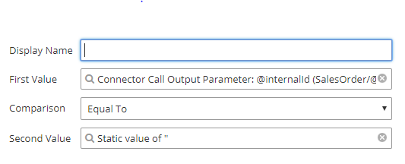

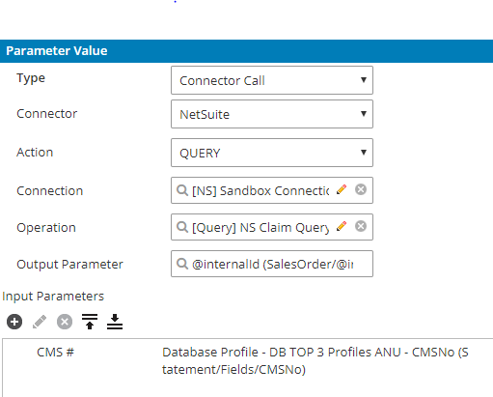

1. **MAP CMS Fields with NetSuite Fields**
2. When Decision shape returns TRUE, then CMS Fields are mapped to NetSuite Fields and Default Item Name (Fee Schedule), amount (0.00) are assigned to NetSuite (In order to create sales order record in NetSuite, item and amount must be given. As CMS Database do not have items, default values are assigned to NetSuite while creating new record).
3. When Decision shape returns FALSE, then CMS Fields are mapped to NetSuite Fields. Here default Item Name and amount are not assigned to NetSuite
4. **Customer Connector Call:**

Connector call is made to NetSuite to find Customer Name in NetSuite. Here Database Client Name calls NetSuite Customer - Company Name and assigns Client Name to Customer Internal ID.

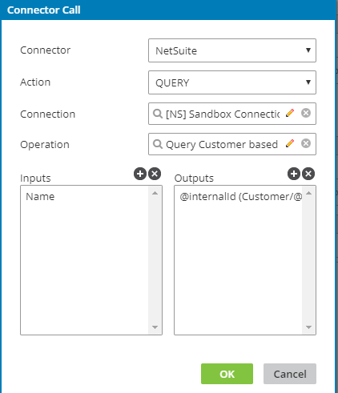

1. **Adjuster/ Vendor Connector Call.**

Connector call is made to NetSuite to find Adjuster Name in NetSuite. Here Database Adjuster ID calls NetSuite Vendor – Adjuster ID and assigns Adjuster ID to Vendor Internal ID.

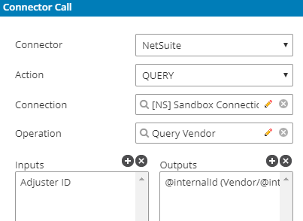

1. Mapping Documents attached as below:

Create



Update:



1. **NetSuite Connector:**

NetSuite connector is used to connect NetSuite.

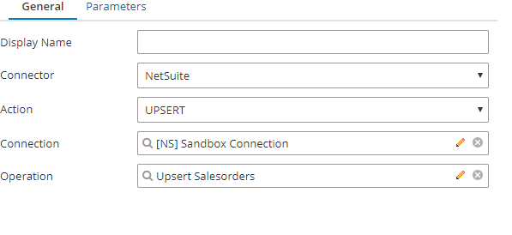

**Deployment Activities:**

|  |  |  |
| --- | --- | --- |
| **Date** | **Version** | **Deployment ID** |
| Date Deployed: 2018-07-23 10:39:44 PM | 3 | 761f83a9-f7c9-4e79-b20e-13f069490d1d |
|  |  |  |
|  |  |  |
|  |  |  |
|  |  |  |
|  |  |  |